Locus of Points at a Fixed Distance from a Point

Definition
# Source: AI Source: Provided by: [Data Path: Persons Table -> ID Column: 1, Name_En Column: Motasem Essam] -> From: [ChatGPT] on [7/25/2026]
The Locus of Points at a Fixed Distance from a Point is the set of all points that are located at the same fixed distance from a given point.
In a Euclidean plane, if $O$is a fixed point and $r>0$is a fixed distance, then the locus of all points $P$satisfying
$$\boxed{OP=r}$$
is a circle centered at $O$with radius $r$.
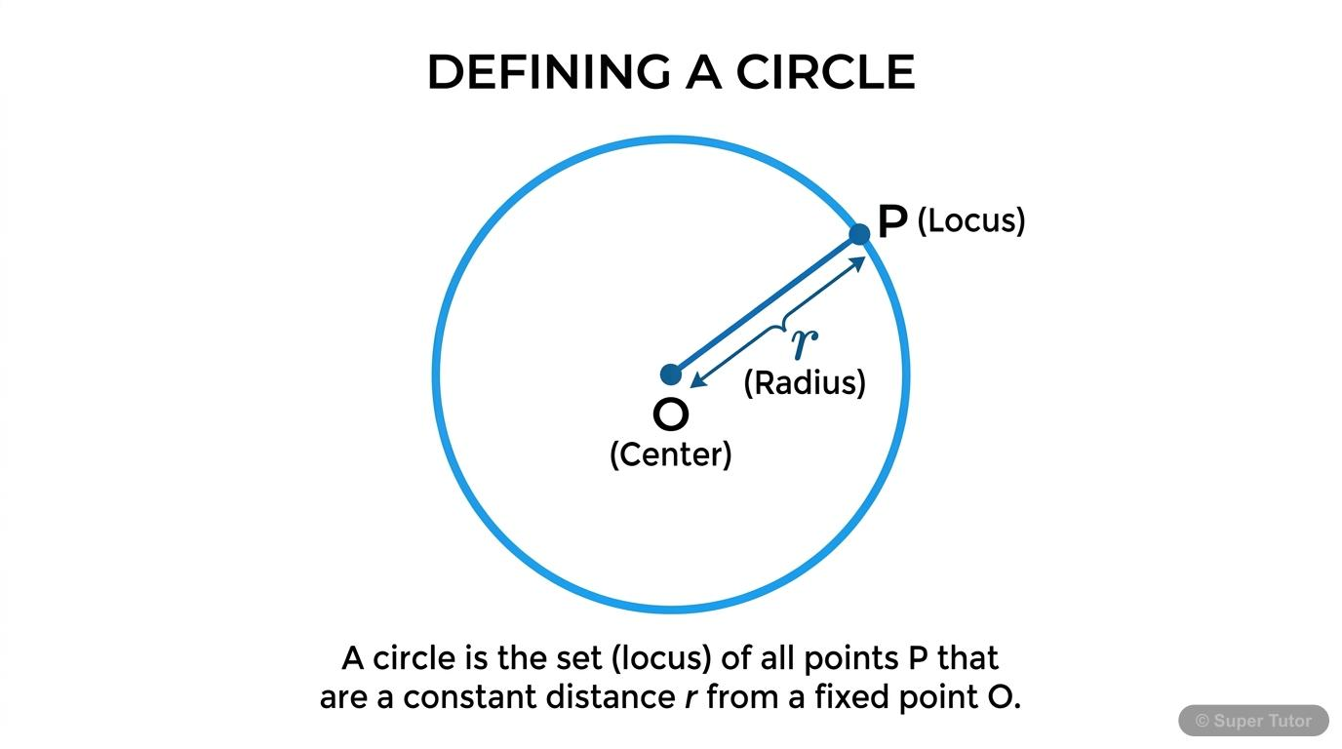
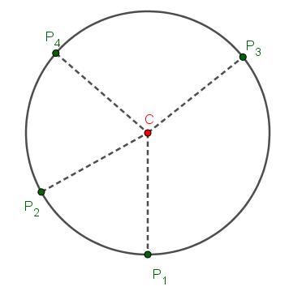
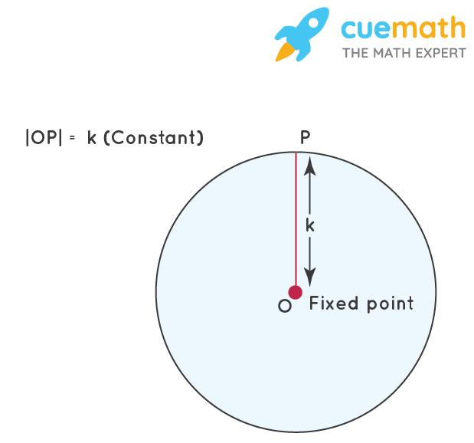
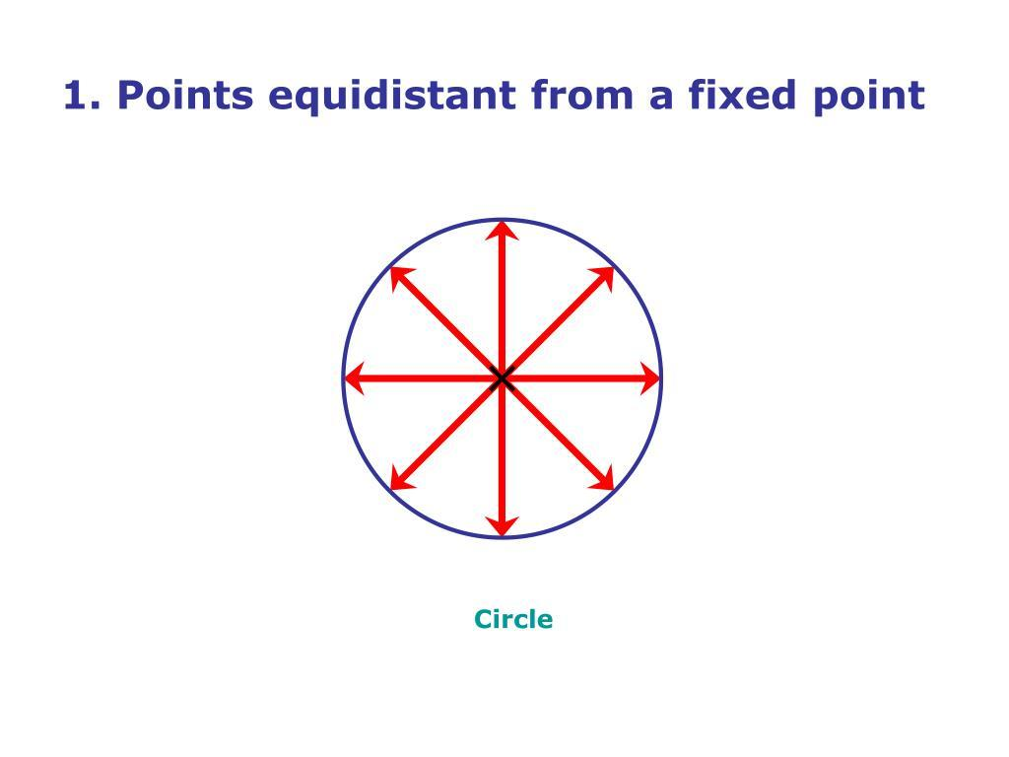
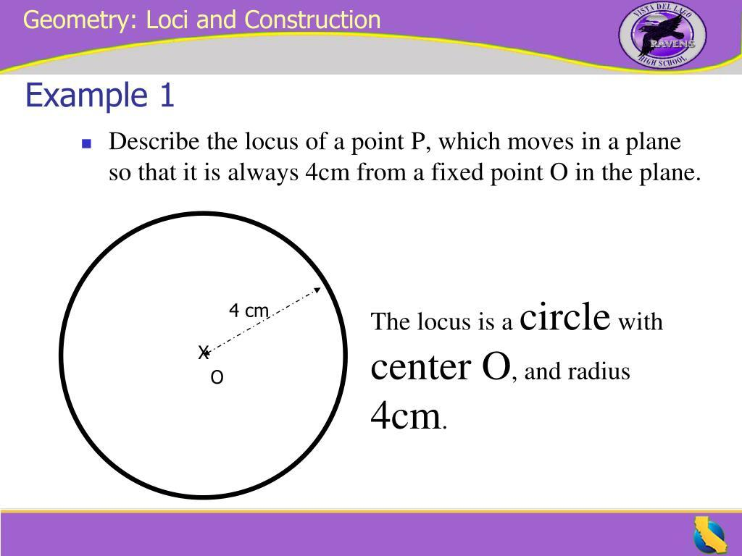

Simple Definition
# Source: AI Source: Provided by: [Data Path: Persons Table -> ID Column: 1, Name_En Column: Motasem Essam] -> From: [ChatGPT] on [7/25/2026]
All points that are a fixed distance from one fixed point form a circle.
For example, all points exactly $5$cm from point $O$form a circle with:
- center $O$
- radius $5$cm.
$$\boxed{OP=5}$$

Fundamental Concept
# Source: AI Source: Provided by: [Data Path: Persons Table -> ID Column: 1, Name_En Column: Motasem Essam] -> From: [ChatGPT] on [7/25/2026]
There are two important elements:
Fixed Point
The fixed point is usually called the center.
Let it be:
$$O.$$
Fixed Distance
Let the fixed distance be:
$$r.$$
We search for every point $P$satisfying:
$$OP=r.$$
The collection of all such points is the locus.
Therefore:
$$\boxed{\text{Fixed Point}+\text{Fixed Distance}→\text{Circle}}$$

Geometric Construction
# Source: AI Source: Provided by: [Data Path: Persons Table -> ID Column: 1, Name_En Column: Motasem Essam] -> From: [ChatGPT] on [7/25/2026]
Suppose the fixed point is $O$and the fixed distance is $r=4$.
Choose any point $P$satisfying:
$$OP=4.$$
Rotate $P$around $O$while keeping the distance from $O$equal to $4$.
Every resulting point satisfies:
$$OP=4.$$
The complete set of these points forms:
$$\boxed{\text{A circle centered at }O\text{ with radius }4}$$
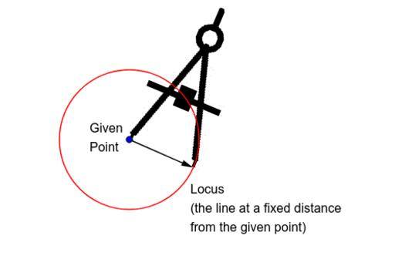
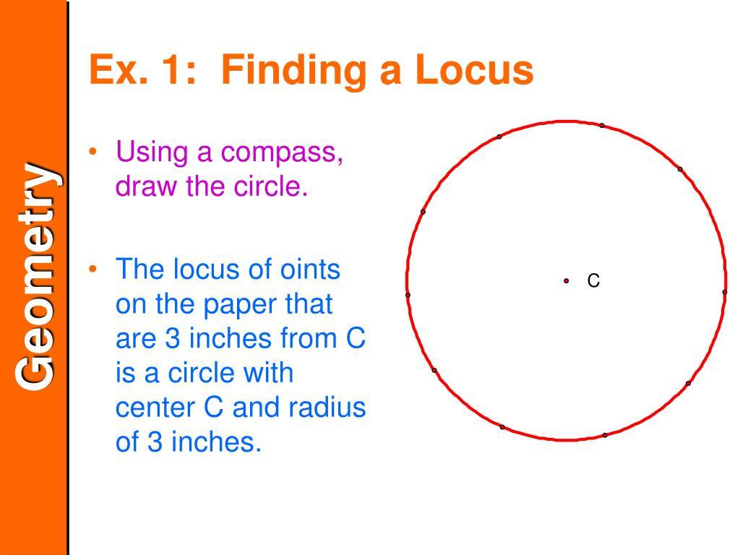
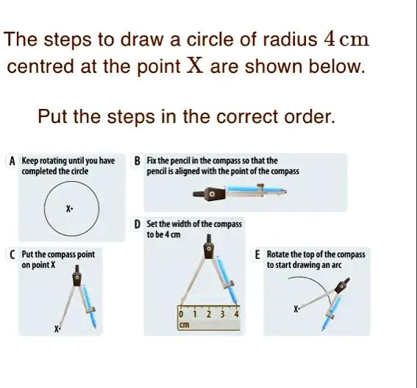
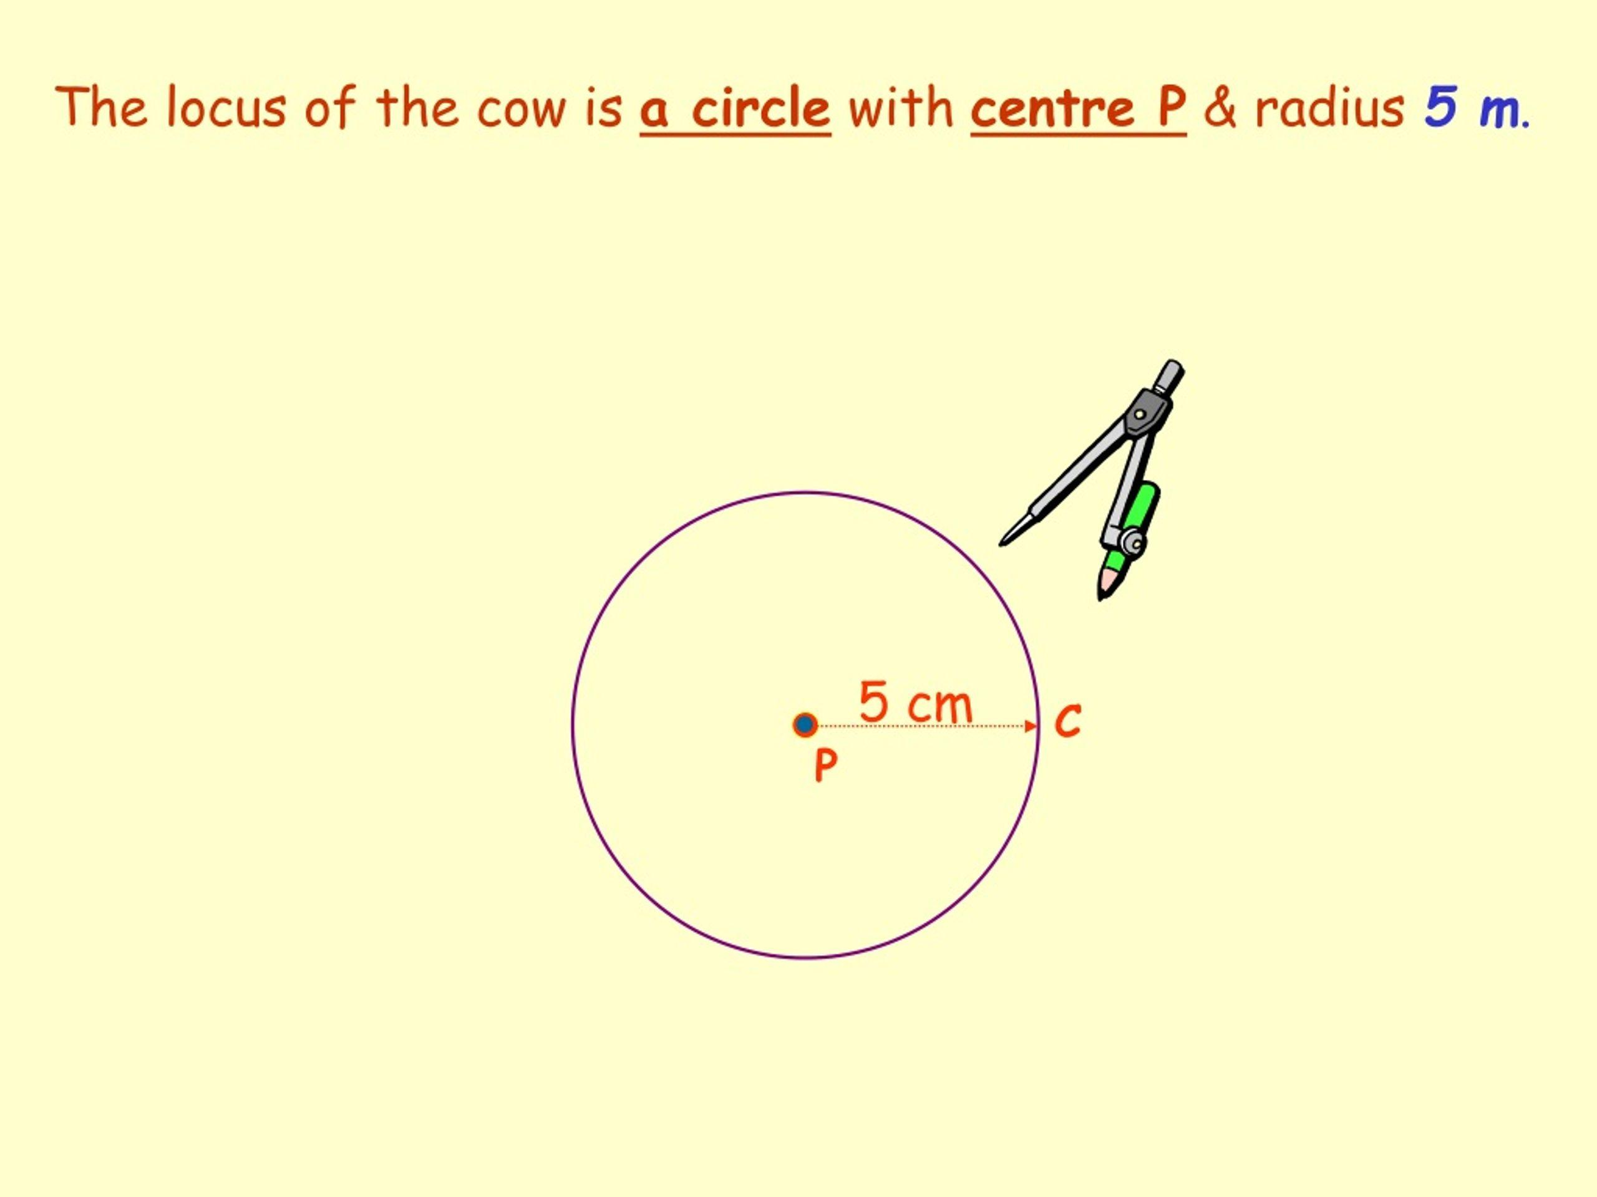
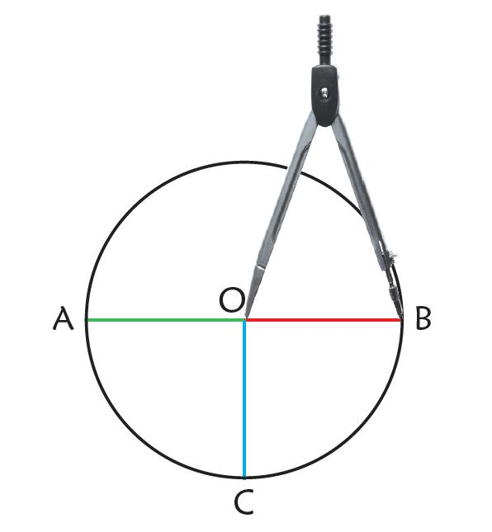

Mathematical Representation
# Source: AI Source: Provided by: [Data Path: Persons Table -> ID Column: 1, Name_En Column: Motasem Essam] -> From: [ChatGPT] on [7/25/2026]
The locus can be represented as:
$$\boxed{\left\{P:OP=r\right\}}$$
This means:
the set of all points $P$whose distance from $O$is $r$.
If:
$$O=\left(h , k\right)$$
and:
$$P=\left(x , y\right),$$
then the distance formula gives:
$$OP=\sqrt{{\left(x-h\right)}^{2}+{\left(y-k\right)}^{2}}.$$
Since:
$$OP=r,$$
we obtain:
$$\sqrt{{\left(x-h\right)}^{2}+{\left(y-k\right)}^{2}}=r.$$
Squaring both sides:
$$\boxed{{\left(x-h\right)}^{2}+{\left(y-k\right)}^{2}=r^{2}}.$$
This is the standard equation of a circle.

Example 1 — Center at the Origin
# Source: AI Source: Provided by: [Data Path: Persons Table -> ID Column: 1, Name_En Column: Motasem Essam] -> From: [ChatGPT] on [7/25/2026]
Let:
$$O=\left(0 , 0\right)$$
and suppose the fixed distance is:
$$r=5.$$
The locus is:
$$x^{2}+y^{2}=25.$$
Therefore:
$$\boxed{x^{2}+y^{2}=25}$$
represents the circle centered at the origin with radius $5$.

Example 2 — Center Not at the Origin
# Source: AI Source: Provided by: [Data Path: Persons Table -> ID Column: 1, Name_En Column: Motasem Essam] -> From: [ChatGPT] on [7/25/2026]
Suppose:
$$O=\left(3 , 2\right)$$
and the fixed distance is:
$$r=4.$$
The locus satisfies:
$${\left(x-3\right)}^{2}+{\left(y-2\right)}^{2}=16.$$
Therefore:
$$\boxed{{\left(x-3\right)}^{2}+{\left(y-2\right)}^{2}=16}.$$
The circle has:
- center: $\left(3 , 2\right)$
- radius: $4$.

Example 3 — Checking Whether a Point Belongs to the Locus
# Source: AI Source: Provided by: [Data Path: Persons Table -> ID Column: 1, Name_En Column: Motasem Essam] -> From: [ChatGPT] on [7/25/2026]
Suppose the locus is:
$${\left(x-2\right)}^{2}+{\left(y-1\right)}^{2}=25.$$
The center is:
$$O=\left(2 , 1\right)$$
and the radius is:
$$r=5.$$
Consider:
$$P=\left(5 , 5\right).$$
Calculate:
$$OP=\sqrt{{\left(5-2\right)}^{2}+{\left(5-1\right)}^{2}} \\ =\sqrt{9+16} \\ =5.$$
Therefore:
$$\boxed{P\text{ lies on the locus}.}$$

Points Inside and Outside the Locus
# Source: AI Source: Provided by: [Data Path: Persons Table -> ID Column: 1, Name_En Column: Motasem Essam] -> From: [ChatGPT] on [7/25/2026]
The equation
$$OP=r$$
describes only the boundary circle.
There are three different conditions:
On the circle
$$\boxed{OP=r}$$
Inside the circle
$$\boxed{OP<r}$$
Outside the circle
$$\boxed{OP>r}$$
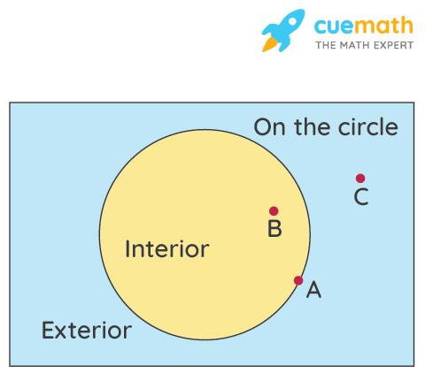
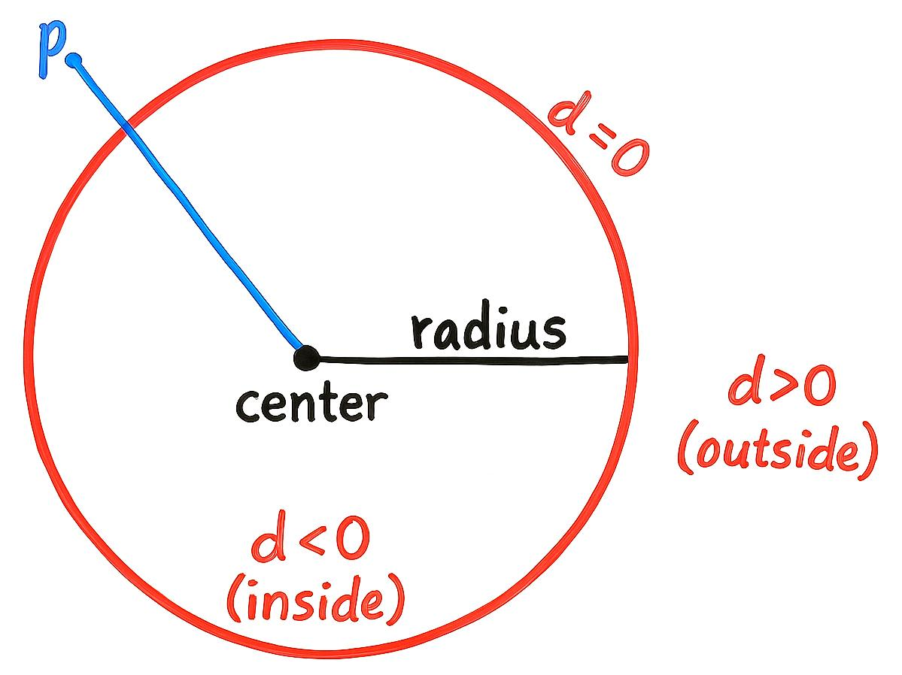
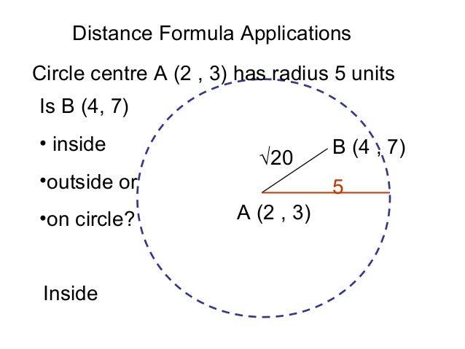
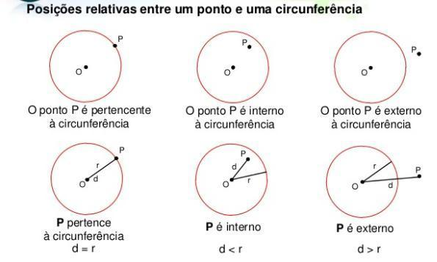
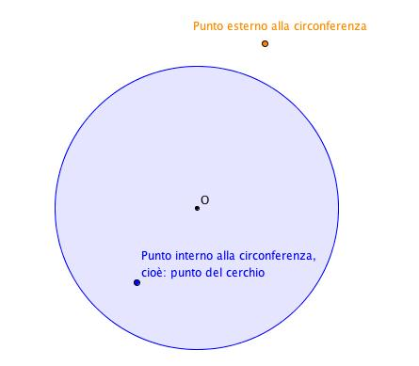
In coordinate form:
On the circle
$$\boxed{{\left(x-h\right)}^{2}+{\left(y-k\right)}^{2}=r^{2}}$$
Inside the circle
$$\boxed{{\left(x-h\right)}^{2}+{\left(y-k\right)}^{2}<r^{2}}$$
Outside the circle
$$\boxed{{\left(x-h\right)}^{2}+{\left(y-k\right)}^{2}>r^{2}}$$

Circle vs. Disk
# Source: AI Source: Provided by: [Data Path: Persons Table -> ID Column: 1, Name_En Column: Motasem Essam] -> From: [ChatGPT] on [7/25/2026]
This distinction is important in locus problems.
Circle
The circle consists only of points exactly $r$units from $O$:
$$\boxed{OP=r}.$$
Closed Disk
The closed disk consists of points whose distance is at most $r$:
$$\boxed{OP≤r}.$$
Open Disk
The open disk consists of points whose distance is less than $r$:
$$\boxed{OP<r}.$$
Therefore:
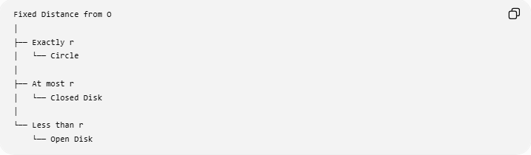
Fixed Distance from O
│
├── Exactly r
│ └── Circle
│
├── At most r
│ └── Closed Disk
│
└── Less than r
└── Open Disk

Three-Dimensional Version
# Source: AI Source: Provided by: [Data Path: Persons Table -> ID Column: 1, Name_En Column: Motasem Essam] -> From: [ChatGPT] on [7/25/2026]
The result changes in three-dimensional Euclidean space.
If $O$is a fixed point in space and every point $P$satisfies:
$$OP=r,$$
then the locus is a sphere, not a circle.
Thus:
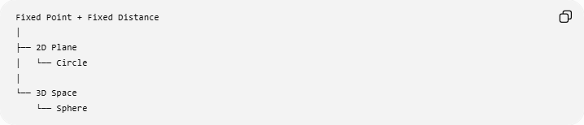
Fixed Point + Fixed Distance
│
├── 2D Plane
│ └── Circle
│
└── 3D Space
└── Sphere
In three-dimensional coordinates, if:
$$O=\left(h , k , l\right),$$
then:
$$\boxed{{\left(x-h\right)}^{2}+{\left(y-k\right)}^{2}+{\left(z-l\right)}^{2}=r^{2}}$$
is the equation of the sphere.

Higher-Dimensional Generalization
# Source: AI Source: Provided by: [Data Path: Persons Table -> ID Column: 1, Name_En Column: Motasem Essam] -> From: [ChatGPT] on [7/25/2026]
The same idea extends to higher-dimensional Euclidean spaces.
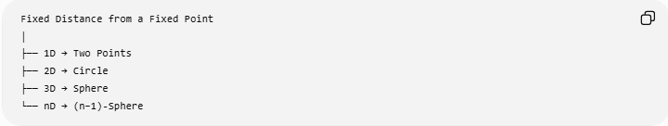
Fixed Distance from a Fixed Point
│
├── 1D → Two Points
├── 2D → Circle
├── 3D → Sphere
└── nD → (n−1)-Sphere
For example:
- In one dimension, points at distance $r$from $O$are:
$$O-r, O+r.$$
- In two dimensions: circle.
- In three dimensions: sphere.
The general object is called an $n$-sphere in $n$-dimensional Euclidean space.

Fixed Distance as a Locus Condition
# Source: AI Source: Provided by: [Data Path: Persons Table -> ID Column: 1, Name_En Column: Motasem Essam] -> From: [ChatGPT] on [7/25/2026]
A locus problem can be written in the general form:
$$\boxed{\text{Find all points }P\text{ satisfying a condition.}}$$
For this particular locus:
$$\boxed{OP=r}.$$
The process is:
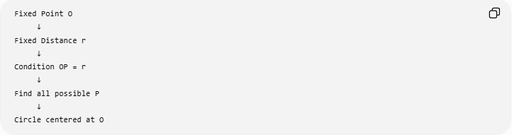
Fixed Point O
↓
Fixed Distance r
↓
Condition OP = r
↓
Find all possible P
↓
Circle centered at O

Example 4 — Real-World Interpretation
# Source: AI Source: Provided by: [Data Path: Persons Table -> ID Column: 1, Name_En Column: Motasem Essam] -> From: [ChatGPT] on [7/25/2026]
Suppose a person must remain exactly $100$meters from a fixed observation point $O$.
Every possible position satisfies:
$$OP=100\text{ m}.$$
Therefore, on a flat plane, the possible positions form a circle:
$$\boxed{\text{Circle centered at }O\text{ with radius }100\text{ m}}$$
The condition does not describe the entire circular region.
Only the boundary is included.

Example 5 — Fixed Distance from a Given Point
# Source: AI Source: Provided by: [Data Path: Persons Table -> ID Column: 1, Name_En Column: Motasem Essam] -> From: [ChatGPT] on [7/25/2026]
Given:
$$A=\left(1 , -2\right)$$
and fixed distance:
$$r=3.$$
The locus of points $P=\left(x , y\right)$satisfying:
$$AP=3$$
is:
$$\sqrt{{\left(x-1\right)}^{2}+{\left(y+2\right)}^{2}}=3.$$
Squaring:
$$\boxed{{\left(x-1\right)}^{2}+{\left(y+2\right)}^{2}=9}.$$
Therefore:
- center $=\left(1 , -2\right)$
- radius $=3$.

Relationship to Other Loci
# Source: AI Source: Provided by: [Data Path: Persons Table -> ID Column: 1, Name_En Column: Motasem Essam] -> From: [ChatGPT] on [7/25/2026]
The locus of a fixed distance from a point is one of the fundamental geometric loci.
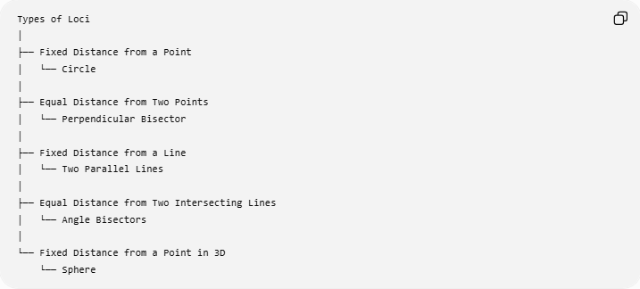
Types of Loci
│
├── Fixed Distance from a Point
│ └── Circle
│
├── Equal Distance from Two Points
│ └── Perpendicular Bisector
│
├── Fixed Distance from a Line
│ └── Two Parallel Lines
│
├── Equal Distance from Two Intersecting Lines
│ └── Angle Bisectors
│
└── Fixed Distance from a Point in 3D
└── Sphere
This makes the fixed-distance locus a fundamental building block for many other constructions.

Comparison with the Perpendicular Bisector
# Source: AI Source: Provided by: [Data Path: Persons Table -> ID Column: 1, Name_En Column: Motasem Essam] -> From: [ChatGPT] on [7/25/2026]
There is an important difference between:
Fixed distance from one point
$$PA=r$$
The locus is:
$$\boxed{\text{Circle centered at }A}.$$
Equal distance from two points
$$PA=PB$$
The locus is:
$$\boxed{\text{Perpendicular bisector of }\overset{‾}{AB}}.$$
Therefore:
$$\boxed{PA=r≠PA=PB}$$
The first uses a fixed numerical distance.
The second uses equality between two distances.

Important Properties
# Source: AI Source: Provided by: [Data Path: Persons Table -> ID Column: 1, Name_En Column: Motasem Essam] -> From: [ChatGPT] on [7/25/2026]
The locus has several important properties.
1. Every point on the locus has the same distance
$$\boxed{OP=r}.$$
2. The fixed point is the center
$$\boxed{O=\text{center}}.$$
3. The fixed distance is the radius
$$\boxed{r=\text{radius}}.$$
4. The locus is closed
A circle contains all points satisfying the exact equality.
5. The locus is continuous
There are infinitely many points satisfying:
$$OP=r.$$
6. Every radius has the same length
For every point $P$on the locus:
$$OP=r.$$

Construction Using Compass and Straightedge
# Source: AI Source: Provided by: [Data Path: Persons Table -> ID Column: 1, Name_En Column: Motasem Essam] -> From: [ChatGPT] on [7/25/2026]
If the fixed point $O$and fixed distance $r$are given:
Step 1
Place the compass point at:
$$O.$$
Step 2
Set the compass opening to:
$$r.$$
Step 3
Rotate the compass around $O$.
Result
The resulting curve is:
$$\boxed{\text{The locus of points at distance }r\text{ from }O}.$$
Therefore, the construction produces a circle.
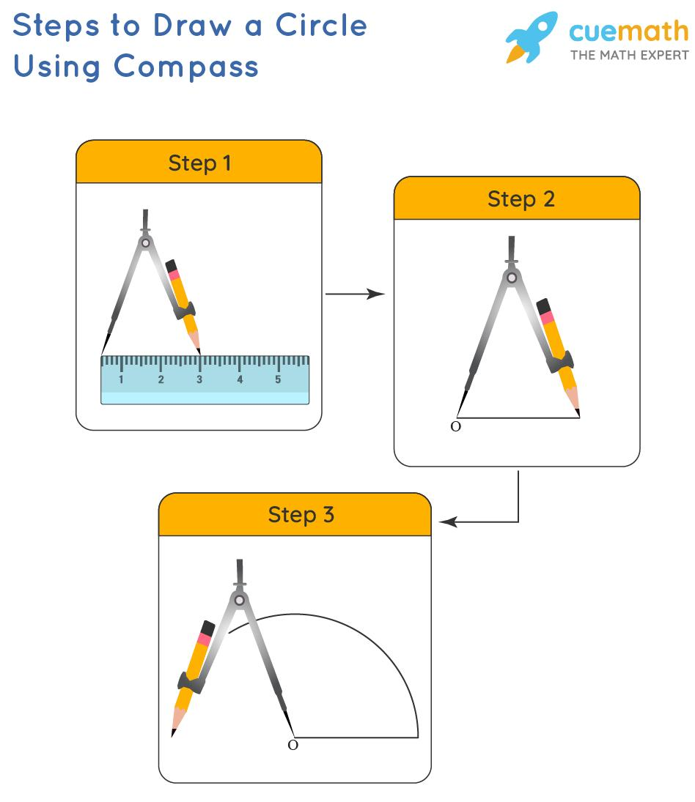

Classification
# Source: AI Source: Provided by: [Data Path: Persons Table -> ID Column: 1, Name_En Column: Motasem Essam] -> From: [ChatGPT] on [7/25/2026]
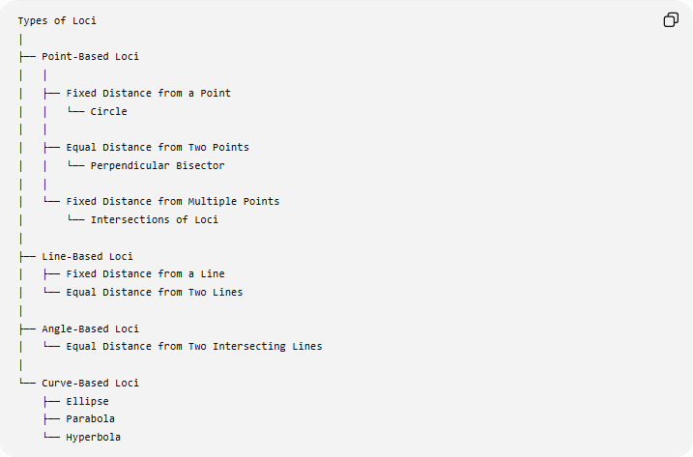
Types of Loci
│
├── Point-Based Loci
│ │
│ ├── Fixed Distance from a Point
│ │ └── Circle
│ │
│ ├── Equal Distance from Two Points
│ │ └── Perpendicular Bisector
│ │
│ └── Fixed Distance from Multiple Points
│ └── Intersections of Loci
│
├── Line-Based Loci
│ ├── Fixed Distance from a Line
│ └── Equal Distance from Two Lines
│
├── Angle-Based Loci
│ └── Equal Distance from Two Intersecting Lines
│
└── Curve-Based Loci
├── Ellipse
├── Parabola
└── Hyperbola
More specifically:
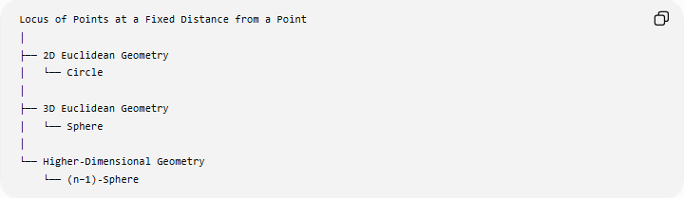
Locus of Points at a Fixed Distance from a Point
│
├── 2D Euclidean Geometry
│ └── Circle
│
├── 3D Euclidean Geometry
│ └── Sphere
│
└── Higher-Dimensional Geometry
└── (n−1)-Sphere

Key Formulas
# Source: AI Source: Provided by: [Data Path: Persons Table -> ID Column: 1, Name_En Column: Motasem Essam] -> From: [ChatGPT] on [7/25/2026]
General geometric form
$$\boxed{OP=r}$$
Circle centered at the origin
$$\boxed{x^{2}+y^{2}=r^{2}}$$
Circle with center $\left(h , k\right)$
$$\boxed{{\left(x-h\right)}^{2}+{\left(y-k\right)}^{2}=r^{2}}$$
Sphere with center $\left(h , k , l\right)$
$$\boxed{{\left(x-h\right)}^{2}+{\left(y-k\right)}^{2}+{\left(z-l\right)}^{2}=r^{2}}$$
Interior region
$$\boxed{OP<r}$$
Closed disk
$$\boxed{OP≤r}$$
Exterior
$$\boxed{OP>r}$$

Classification Summary
# Source: AI Source: Provided by: [Data Path: Persons Table -> ID Column: 1, Name_En Column: Motasem Essam] -> From: [ChatGPT] on [7/25/2026]
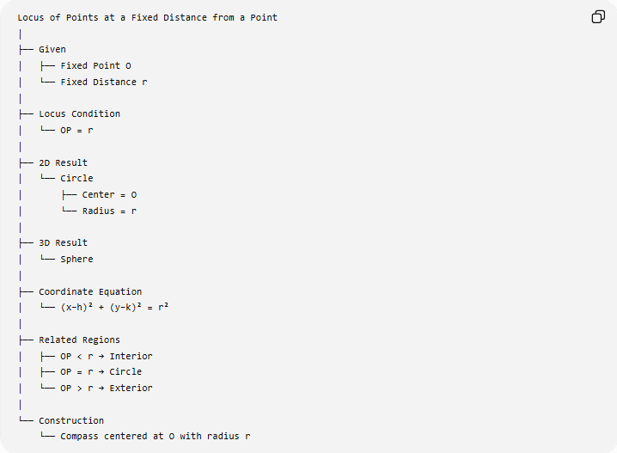
Locus of Points at a Fixed Distance from a Point
│
├── Given
│ ├── Fixed Point O
│ └── Fixed Distance r
│
├── Locus Condition
│ └── OP = r
│
├── 2D Result
│ └── Circle
│ ├── Center = O
│ └── Radius = r
│
├── 3D Result
│ └── Sphere
│
├── Coordinate Equation
│ └── (x−h)² + (y−k)² = r²
│
├── Related Regions
│ ├── OP < r → Interior
│ ├── OP = r → Circle
│ └── OP > r → Exterior
│
└── Construction
└── Compass centered at O with radius r

Conclusion
# Source: AI Source: Provided by: [Data Path: Persons Table -> ID Column: 1, Name_En Column: Motasem Essam] -> From: [ChatGPT] on [7/25/2026]
The Locus of Points at a Fixed Distance from a Point is one of the most fundamental types of loci.
Given a fixed point $O$and a fixed distance $r$, every point $P$satisfying
$$\boxed{OP=r}$$
forms a circle in the Euclidean plane:
$$\boxed{\text{Locus}=\text{Circle}\left(O , r\right)}.$$
In three-dimensional space, the corresponding locus is a sphere:
$$\boxed{\text{Locus}=\text{Sphere}\left(O , r\right)}.$$
The central principle is therefore:
$$\boxed{\text{Fixed Point}+\text{Fixed Distance}⟶\text{Circle in 2D}}$$
and
$$\boxed{\text{Fixed Point}+\text{Fixed Distance}⟶\text{Sphere in 3D}}$$

